Chapter 4, Problem 91.

- In the Wheatstone bridge circuit of Fig. 4.147 select the values of R₁ and R₃ such that the bridge can measure R_{x} in the range of 0-10 Ω.
- Repeat for the range of 0-100 Ω.

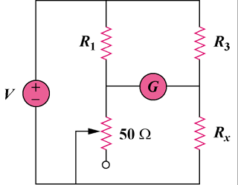

Figure 4.147
For Prob. 4.91.

